­­­­**Report**

Commercialization of space

**Factors contributing for the growth of space Industry**

* **Advances in technology drive cost reduction**

A major driver of growth in the space sector has been the development of new technologies, such as reusable launch vehicles, SmallSats (satellites of low mass and size, usually under 2,600 lbs.), and CubeSats (square shaped miniaturized satellites).Innovation has made it more cost effective to develop new space systems and launch payloads into space, which in turn has enabled a wider range of organizations to participate in the space sector. The development of SmallSats and CubeSats have particularly increased the interest of private companies and government agencies in investing in this field, as it allows for more affordable access to space and new business models, such as constellations (a group of satellites working together as a system with shared control). SmallSats accounted for about 95% of spacecraft launched in 2022.

Percentage of Investments done in each field

* **Increased investment in private sectors**

Another important driver of growth in the space sector has been increased private sector investment. A growing number of venture capital (VC) firms and private equity (PE) firms have been investing in the space sector, and more and more private companies are entering the market to provide space-related products and services. As of the end of 2022, the global space sector had attracted PE investments of about US$272 billion into 1,791 unique companies since 2013. At the same time, investments in the national security space are also rapidly increasing. For instance, in the United States, the FY23 national security space budget allocated US$20.8 billion to National Security Space investment accounts, a 19.5% increase from FY22.

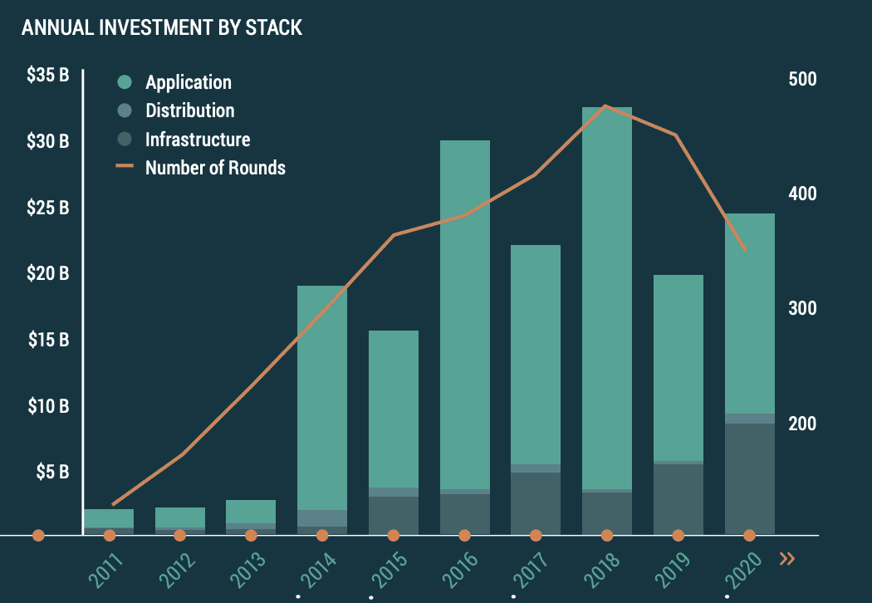

* **Rising demand for space data and related products and services**

The fast-growing space data-as-a-service market, where specialized companies deliver high-quality data directly to their customers, is another key driver.

Government agencies, private companies, and research institutions are all increasingly using space-based data to support a wide range of applications, such as satellite broadband. Communication service providers and earth observation service providers are likely to benefit the most from data generated by satellites.

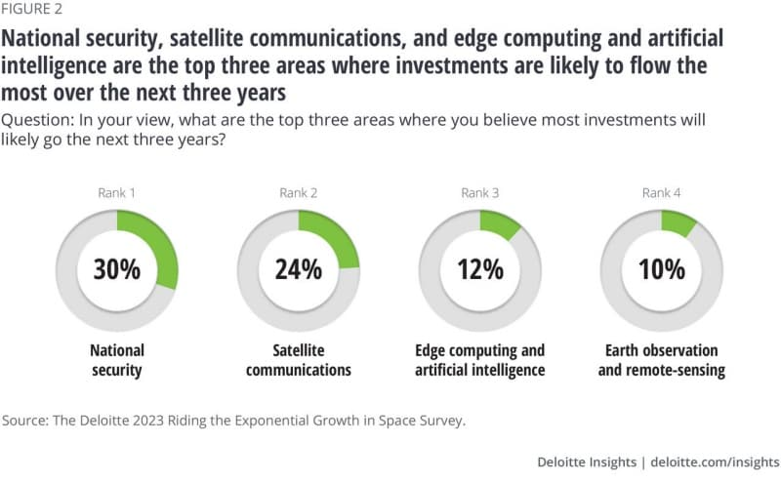

**Overview on companies leading space industry**

1. Virgin Galactic

Virgin Galactic is an aerospace and space travel company owned by Sir Richard Branson pioneering human spaceflight for private individuals and researchers with its advanced air and space vehicles. It is a private space tourism company that was founded in 2004. In 2023, the company sent it’s first paying customers to the edge of space. They are charging $300,000 each for its suborbital space tourism flights. A total of **1,166** Employees are working in the company currently.

Technical Innovations

**Virgin Galactic's spacecraft fleet includes:**

* + VMS Eve: A custom-built, four-engine, dual mothership
  + VSS Unity: An innovative, reusable suborbital spaceship
  + VSS Imagine: The first Spaceship III in Virgin Galactic's growing fleet

An agreement with Axiom Space, a U.S.-based commercial space company, to support a microgravity research and training mission. The Virgin Galactic spaceflight, tentatively scheduled for next year, will prepare an Axiom Space astronaut for an upcoming trip to orbit, while conducting microgravity research to supplement the work they will do on the International Space Station.

Financials

Virgin Galactic listed into the New York Stock Exchange, trading under the ticker symbol 'SPCE', the first publicly traded space tourism company (i.e., company whose primary business is space tourism). The company raised $450 million through a SPAC merger listing, and company's market value after listing was more than $2.4 billion. At the time, the company claimed to have over 600 customer reservations representing approximately $80 million in total collected deposits and more than $120 million in "potential revenue". They are charging $300,000 each for its suborbital space tourism flights.

But Still according to Financial reports, Virgin Galactic is still in losses and haven’t even reached the break-even point yet. They have sold tickets of 450,000 to around 1000 people but it’s first 600 tickets were sold at 250,000. But it’s still not enough for the company to be profitable. Some estimates say that they have to fly atleast 33 times per quarter to cover break even.

1. Blue Origin

Blue Origin Enterprises, L.P.,commonly referred to as Blue Origin is an American aerospace manufacturer, defense contractor, launch service provider and space technologies company headquartered in Kent, Washington, United States. The company was founded by Jeff Bezos on September 8,2000 and makes makes rocket engines for United Launch Alliance (ULA)'s Vulcan rocket and manufactures their own rockets, spacecraft, satellites, and heavy-lift launch vehicles. The company is the second provider of lunar lander services for NASA's Artemis program and was awarded a **$3.4** billion contract. Currently **11,000** Employees are working the company generating a revenue of 596.4 Million.

Technical Innovations

Reusability**: New Glenn** is a heavy-lift orbital launch vehicle in development by Blue Origin, named after NASA astronaut John Glenn, the first American astronaut to orbit Earth. Information became public in July 2021 that Blue Origin had begun a "**project to develop a fully reusable upper stage for New Glenn**," under the name "**Project Jarvis**", just as SpaceX is aiming to do with their Starship second stage. If Blue Origin is able to realize such a second stage design and bring it into operational use, New Glenn would become a fully-reusable launch vehicle and would benefit from a substantial reduction in cost per launch.

**Solar Cells**: Blue Alchemist is a proposed end-to-end, scalable, autonomous, and commercial solution that produces solar cells from lunar regolith, which is the dust and crushed rock abundant on the surface of the Moon. Based on a process called molten regolith electrolysis, the breakthrough would bootstrap unlimited electricity and power transmission cables anywhere on the surface of the Moon. This process also produces oxygen as a useful byproduct for propulsion and life support.

**Bionic Design:** The innovative ‘biconic’ design is oriented vertically for launch and horizontally for reentry, affording the launch simplicity of a capsule coupled with the reentry advantages of a lifting body. This gives astronauts a larger accessible landing area from any single reentry point, which means more frequent opportunities to conduct an emergency return from the ISS and land safely in the United States, while lowering G-forces the astronauts experience on reentry.

Milestones achieved:

* + Developing reusable rockets
  + Successful vertical landings
  + Partnerships with NASA for lunar exploration
  + 22 successful consecutive missions with the New Shepard rocket
  + Three successful capsule escape tests

Financials

Blue Origin has raised funds over 3 rounds and their major investors are NASA and United states space forces.

Why United States space force?

* The U.S. Space Force plans to award a sole-source contract to Blue Origin for early integration studies for upcoming National Security Space Launch (NSSL) missions to be competitively awarded during fiscal 2025-26,
* The U.S. Space Force and Blue Origin have a Cooperative Research and Development Agreement (CRADA) for the New Glenn Rocket.

What NASA is doing with Blue origin?

* NASA and Blue Origin have a history of working together. In 2010, NASA selected Blue Origin as one of five companies to receive funding for early development work on their own projects.
* In 2023, NASA awarded Blue Origin a $3.4 billion contract to build a lunar lander for a 2029 moon mission. The 50-foot-tall spacecraft, named Blue Moon, can transport four astronauts to the moon's surface.
* Blue Origin is also working with NASA on the Blue Alchemist project, which aims to produce solar cells from lunar regolith.

They have sold tickets worth 100 million dollars for space tourism. The company held a public auction for a seat on its first flight with Bezos, which went under the hammer for $28 million. Virgin Galactic, its nearest rival, asked for $200,000-$500,000 for seats on its future flight. They also have contracts with NASA for which they are awarded funds for their missions.

1. **Sierra Space**

Sierra Space Corporation, commonly referred to as Sierra Space, is a privately held aerospace and space technologies company. he company makes spaceflight hardware for various applications across the industry. It is currently developing the Dream Chaser spaceplane. The spaceplane was selected by NASA to provide services to the International Space Station under NASA's Commercial Resupply Service 2 contract. The company is also in collaboration with Blue Origin to develop large components of the Orbital Reef space station. It has around 2000 employees working under the company and it’s establishes in 6 different locations.

Technical Innovations:

Microgravity: The area where microgravity will have the most profound impact is in life sciences. The life sciences sector in 2023 is valued at $2.83 trillion consisting of the pharmaceutical, biotech and medtech industries. The impact of microgravity holds enormous potential in the treatment, and possible cure of cancer, autoimmune conditions, and other diseases.

Space Mount Technology

Sierra Space has developed an automated solar array manufacturing process using Surface Mount Technology (SMT) to significantly reduce the lead-time of space power.

The SMT solar technology has flight heritage and has been used on several missions to date.

Other Features of our Surface Mount Technology:

• 10% - 40% Increased Power Density

• Reduced Lead Time

• Increased Resiliency

• Lower Cost

Vegetable Production Unit (VEGGIE)

The Vegetable Production Unit (VEGGIE), a modularly designed plant growth unit, was developed and built by Sierra Space and provided to NASA Kennedy Space Center.

VEGGIE was the first platform to be certified to provide ISS-grown produce for crew consumption, making it possible for U.S. astronauts to eat fresh produce for the first time on-orbit in 2015.

All the facilities and environment required to create a Bio-System there in space in Space stations has been majorly taken up by Sierra Space and they are going to implement this in their future Space station – Orbital Reef.

• VEGGIE (VEGITABLE PRODUCTION UNIT)

• APH (ADVANCED PLANT HABITAT)

• ASTRO GARDEN

• MASS MEASUREMENT DEVICE

• TRASH COMPACTION AND PROCESSING SYSTEM

Financials

**Sierra Space**

In funding rounds

* Round is co-led by a Japanese strategic partnership comprising MUFG Bank, Kanematsu, and Tokio Marine & Nichido Fire Insurance; expands Sierra Space global partnership network.
* Also includes investment by General Atlantic, Coatue, Moore Strategic Ventures & Sierra Holding Company with participation from funds and accounts managed by BlackRock Private Equity Partners, AE Industrial Partners and Vice Family Trust.
* Sierra Space increases total investment to $1.7 billion; industry record for combined Series A and B raises.
* Company achieves $5.3 billion valuation in closing $290 million Series B funding round; Sierra Space also has $3.4 billion in active contracts.

Sierra space collab with NASA

* Sierra Space prepares the transition of Dream Chaser® spaceplane into orbital operations for NASA cargo resupply missions to the International Space Station following several years of development.

Growth capital accelerates Sierra Space’s first mover advantage in the deploying the first business-ready commercial space station, continued growth of the national security business and scale of the space systems and components portfolio

The company is running Profitably with getting huge amount of investments and has crossed it’s break even point.

1. **Bigelow Aerospace**

Bigelow Aerospace was an American space design and manufacturing company which closed its doors in 2020. It was an aeronautics and outer space technology company which manufactured and developed expandable space station modules. Bigelow Aerospace was founded by Robert Bigelow in 1998, and was based in North Las Vegas, Nevada. It was funded in large part by the profit Bigelow gained through his ownership of the hotel chain, Budget Suites of America. The company built two unmanned free-flying prototypes that flew in 2006 and 2007 and a module attached to the International Space Station. Bigelow Aerospace announced in 2010 that they intended to create a modular set of space habitats for creating or expanding space stations. Initially it had 88 Employees but during Covid 19, the company was shut down.

In August 2016, NASA selected six U.S. companies to help expand knowledge, commercial capabilities and opportunities in space by developing full-sized ground prototypes and concepts for deep space habitats under the second Next Space Technologies for Exploration Partnerships (NextSTEP) Broad Agency Announcement, or NextSTEP-2. NextSTEP establishes unique public-private partnerships that seek to advance commercial development of space while advancing deep space exploration capabilities to support more extensive human space flight missions in the area of space near the moon that will be the proving ground for Mars.

Technical Innovations

XBASE: **Bigelow Aerospace** will develop and test a prototype of XBASE (Expandable Bigelow Advanced Station Enhancement), a 330-cubic-meter expandable habitat and test platform for deep space hardware. The testing conducted on this platform will advance approaches for deep space missions and serve as a basis for commercialization in low-Earth orbit. XBASE is based on the B-330 expandable spacecraft for the mission-specific purpose of attaching to the International Space Station as a visiting vehicle.

BSO: Bigelow Aerospace is excited to introduce Bigelow Space Operations (BSO), a new commercial space company that is the sales, operational and customer service company that manages and operates space stations developed by Bigelow Aerospace.

B330: The B330 is an autonomous, expandable independent space station that gets to space in a single launch. This large space station can accommodate four people indefinitely and five people for many months. The B330 has evolved from NASA heritage technology from the Transhab program. Expandable habitat technology was created from the Transhab program with the purpose of taking humans to Mars.

Financials:

By 2013, Bigelow had invested US$250 million in the company. Bigelow stated on a number of occasions that he was prepared to fund Bigelow Aerospace with about US$500 million through 2015 in order to achieve launch of full-scale hardware.

As of October 2015 the Bigelow Aerospace website shows several pricing schemes including US$51.25 million for 60 days on a B330 space station. That price covers everything including transport, training, and consumables. For US$25 million Bigelow Aerospace customers can lease a third of a B330 habitat, roughly 110 cubic meters, for a period of 60 days

**Investment vs potential of achievability**

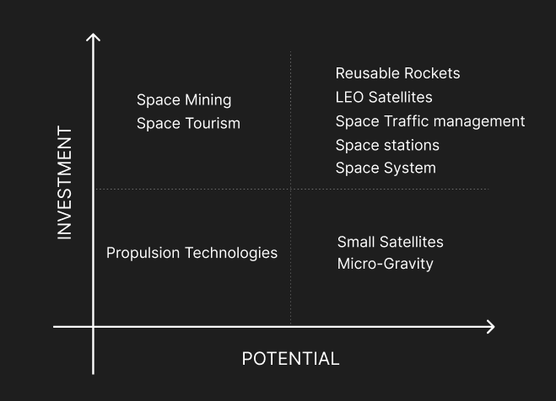

**Risk Analysis**

Consequences of Increasing competition

A greater number and diversity of actors operating in space could generate new or exacerbate old frictions if not responsibly managed. The trend in commercial, civil and military sectors is to replace traditionally large and expensive single geostationary satellite systems with a more distributed system of multiple smaller satellites in LEO. Approximately 11,000 satellites have been launched since Sputnik 1 in 1957, but 70,000 more could enter orbit in the coming decades if proposed plans play out.

An increased number of objects into space increases the risk of collision between satellites which further goes and hits another satellite hence starting a chain reaction of creating Space debris exponentially. This effect is called Kessler’s effect.

**KESSLER EFFECT**

The Kessler Effect First identified by NASA scientist Donald Kessler in 1978, this describes a scenario where the density of objects (satellites and debris) in LEO is high enough that collisions between objects could cause a cascade in which each collision generates space debris that increases the likelihood of further collisions and an exponential growth of debris. One implication is that the distribution of debris in orbit could render space activities and the use of satellites in specific orbital ranges difficult for many generations.

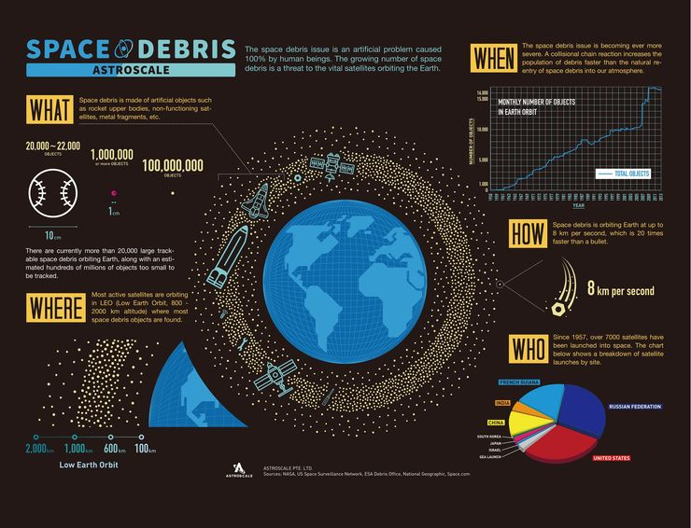

**Solar Disruption**

**I**n February 2022, SpaceX launched 49 Starlink satellites from a Falcon 9 rocket into low-earth orbit. A day after being deployed, the company reported that a geomagnetic storm disrupted the trajectories of 40 of their satellites, causing them to burn up upon reentry to the planet. While the impact to date on satellites has been limited, it’s important to understand that solar storms happen with some regularity, due to the sun’s 11-year solar cycle**.**

Fortunately, most solar storms do not directly affect humans, but the magnetic disturbances can change the density of the atmosphere in which satellites are moving (as was the case in 2022 with the Starlink satellites) or far more importantly, they can create magnetic activity that induces potentially problematic electric currents.

**A massive solar storm in 1967 came close to spurring a global nuclear war between the United States and the USSR.**

While the breakdown of communications and power systems can indeed be concerning, a massive solar storm in 1967 came close to spurring a global nuclear war between the United States and the USSR. In May of that year, a geomagnetic storm disrupted the radars of America’s Ballistic Missile Early Warning System. It appeared to many military leaders as Soviet radar jamming these radar immediately prior to a nuclear attack on the United States. Commanders put US forces in a “ready to launch” status, but because of the Air Force’s emerging interest in solar storms and space weather, solar forecasters at NORAD were able to convince military commanders that the radar attacks came from the sun. Yes, it’s true, space weathermen prevented nuclear war!

**In year 2024,** It is expected that the solar activity is gonna be more active than the last two decades and can lead to blacking out of satellites.

**Political Risks**

“If any country wants to mine the moon, we must follow the Artemis Accords”.

The Accord claims to establish a common set of principles to govern the civil exploration and use of outer space. Accords are conflicting with international space laws in the following ways:

• First, the Artemis Accords go beyond simply rejecting the unpopular 1979 Moon Agreement, which declared lunar resources to be the “common heritage of mankind” and committed parties to establish an international regime to oversee space mining. Only 18 countries have signed the treaty.In its place, the accords envisage a US-centric framework of bilateral agreements in which “partner nations” agree to follow US-drafted rules.

• Second, the accords introduce the concept of “safety zones” around lunar operations. Although territorial claims in space are prohibited under international law, these safety zones would seek to protect commercial and scientific sites from inadvertent collisions and other forms of “harmful interference”. What kinds of conduct could count as harmful interference remains to be determined.

The accords claim to comply with the 1967 Outer Space Treaty, a widely supported agreement that declared space the “province of all mankind” and permitted commercial resource exploitation as a “peaceful use” of space.

However, in practice, the accords have the potential to challenge the Outer Space Treaty’s ban on territorial claims in space. They could also intensify international conflict over space resources.

**Is International Laws about space being equal to all mankind invalid now?**

The real difference between the Artemis Accords and an international framework negotiated within the UN turns on whether space will be treated as a global commons when space mining begins.

The idea that the profits of space resource extraction should be shared via an international body garnered much support among developing nations and their supporters in the 1960s and ‘70s.

But entrepreneurs in the US space sector have long contested the global commons principle. And the US rejection of a global commons framework for space is ultimately a rejection of profit sharing. Mining and tech companies would retain all the profits.

**SAFETY ZONES**

The safety zones under the Artemis Accords would require all commercial and government ventures to share information on the location and nature of their space operations and notify and coordinate any approaches to other sites.

The practical sense of safety zones is clear. However, such zones seriously test a fundamental principle of the Outer Space Treaty – the ban on territorial claims in space.

https://theconversation.com/could-corporations-control-territory-in-space-under-new-us-rules-it-might-be-possible-138939

**What are the goals of new space race?**

For example, there are numerous objectives behind the return to the Moon via the Artemis missions, and the proposed Moon Bases the USA and China/Russia intend to build. Using the Moon as a launch pad for going to Mars is one goal and mining the Moon for resources is another.

Minerals:

evidence has been found for deposits of metal oxides in some of the large craters of the Moon. It’s also believed the Moon contains reserves of silicon, titanium, rare earth metals and aluminium.

Humanity is destined to spend more time there, digging beneath the surface in pursuit of these metals, which are used in vital modern technologies. Many countries have the incentive to go after them, especially those that don’t want to rely on China, which currently holds a third of the world’s known reserves.\

Countries are also after helium-3. Theoretically, helium-3 can be used to create nuclear fusion – the Holy Grail of energy production – as it would produce higher amounts of energy than nuclear fission but is much less radioactive. On Earth only about 0.0001 per cent of helium is helium-3, but on the Moon there may be a million tonnes of the stuff.

**What tensions are most likely to occur in space?**

Tensions will more likely arise around attacking satellites. Part of countries’ early-warning systems of a nuclear launch are within their satellites. If a nation thought these machines were being threatened, the temptation to take pre-emptive action would increase.

Without satellites, international communication networks and global positioning systems would not exist. Jam, spoof or destroy these satellites and your grocery delivery van can’t find you, the emergency services are lost, ships drift off course and a major industrialised economy such as the UK loses an estimated £1 billion a day. Their importance to modern life cannot be overstated and their function in the military is now key to modern warfare.